Verification of Ohm’s Law

using PSPICE Simulation

Lab # 3



**CSE-103L Circuit & System Lab**

Submitted by: Maaz Habib

Registration No: 20PWCSE1952

Class Section: C

“On my honor, as student of University of Engineering and Technology, I have neither given nor received unauthorized assistance on this academic work.”

Submitted to:

**SIR FAIZ ULLAH**

**(May 19, 2021)**

**Department of Computer Systems Engineering**

**University of Engineering and Technology, Peshawar**

Experiment # 3

**Verification of Ohm’s Law using PSPICE Simulation**

Objective:

To verify ohm’s law on electric circuit simulation tool like PSPICE.

## Ohm's Law discovery:

A German scientist named Georg Ohm performed many experiments in an effort to show a link between the three. There is a mathematical relationship which links current, voltage and resistance. Back in the days when he was performing his experiments there were no meters as we have now a days. Only after considerable effort and at the second attempt did he manage to devise what we know today as Ohm's Law.

Ohm’s Law:

Ohm's law stated that:

“**The**[**current**](https://en.wikipedia.org/wiki/Electric_current)**through a**[**conductor**](https://en.wikipedia.org/wiki/Electrical_conductor)**between two points is directly**[**proportional**](https://en.wikipedia.org/wiki/Proportionality_(mathematics))**to the**[**voltage**](https://en.wikipedia.org/wiki/Voltage)**across the two points”.**

In simple words by doubling the voltage across a circuit the current will also double. However if the resistance is doubled the current will fall by half.

## Ohm's Law formula:

The Ohm's Law formula or equation is very straightforward.

Ohm's law can be expressed in a mathematical form:

V=IR

Here:  
    V = voltage expressed in Volts  
    I = current expressed in Amps  
    R = resistance expressed in Ohms

The formula can be used when two quantities are known the third quantity is unknow and can be calculated. It can be also be written as:

I= V/R

R=V/I

## Ohm's law triangle:

To easily remember the formula, it is possible to use a triangle with one side horizontal and the peak at the top like a pyramid. This is sometimes known as the Ohm's law triangle.

At top corner of the triangle is the letter “V”, in the left hand corner the letter “I” , and in the right hand bottom corner “R”.

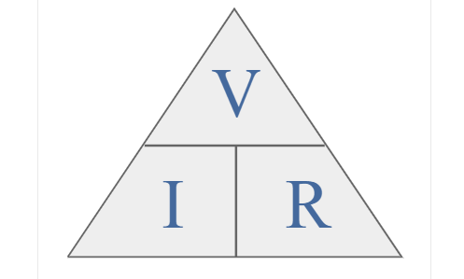

To use the triangle, cover the unknown quantity and then calculate it by using the other two known quantity. If they are in one line then they are multiplied. If one quantity is on top of the other then they should be divided. In other words, if current has to be calculated the voltage is divided by the resistance i.e., V/R.

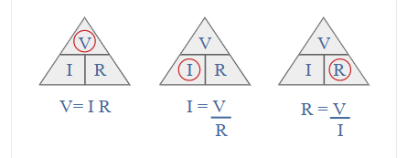

If the voltage has to be calculated then it is found by multiplying the current by the resistance i.e. I x R.

## Ohms Law calculation example:

If a voltage of 10 volts is placed across a 500 ohm resistor determine the amount of current that will flow.

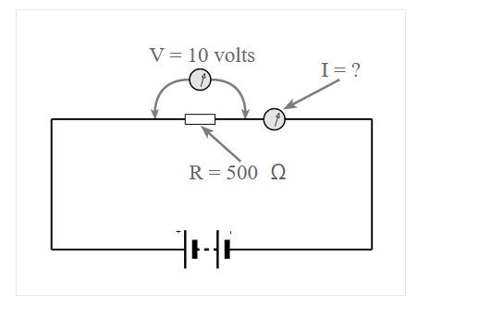

Looking at the Ohms Law triangle the current is the unknown leaving the voltage and resistance as the known values.

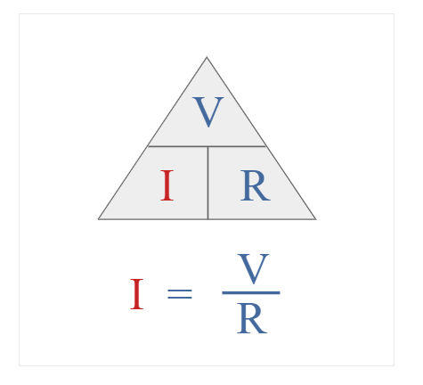

In this way the current is found by dividing the voltage by the resistance.

I = V/R

=10/500

=0.02A

=20mA

Circuit Diagram:

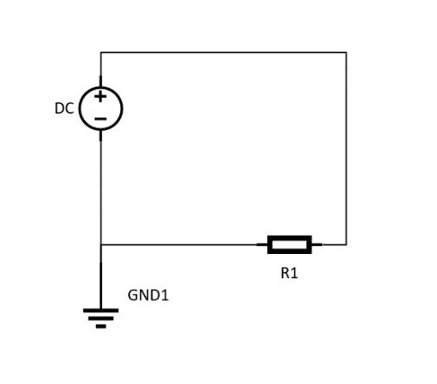

PSPICE:

   PSPICE is a circuit analysis tool that allows the user to simulate a circuit and extract key voltages and currents. Information is entered into PSPICE via one of two methods; they are a typed 'Net List' or by designing a visual a schematic which is transformed into a netlist.

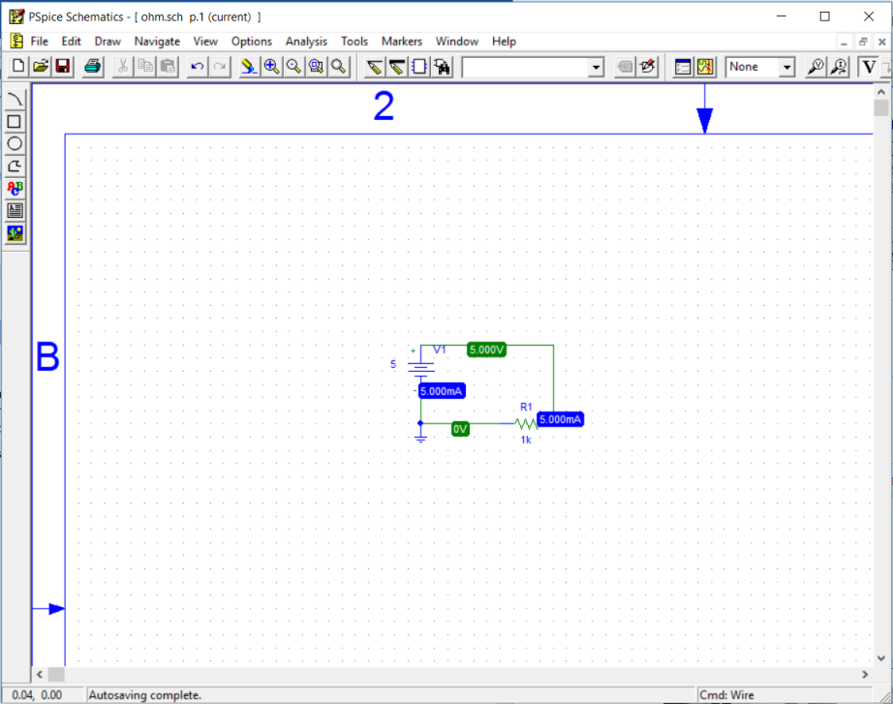

  We can verify ohm’s law using PSPICE.

1. **For 5v:**

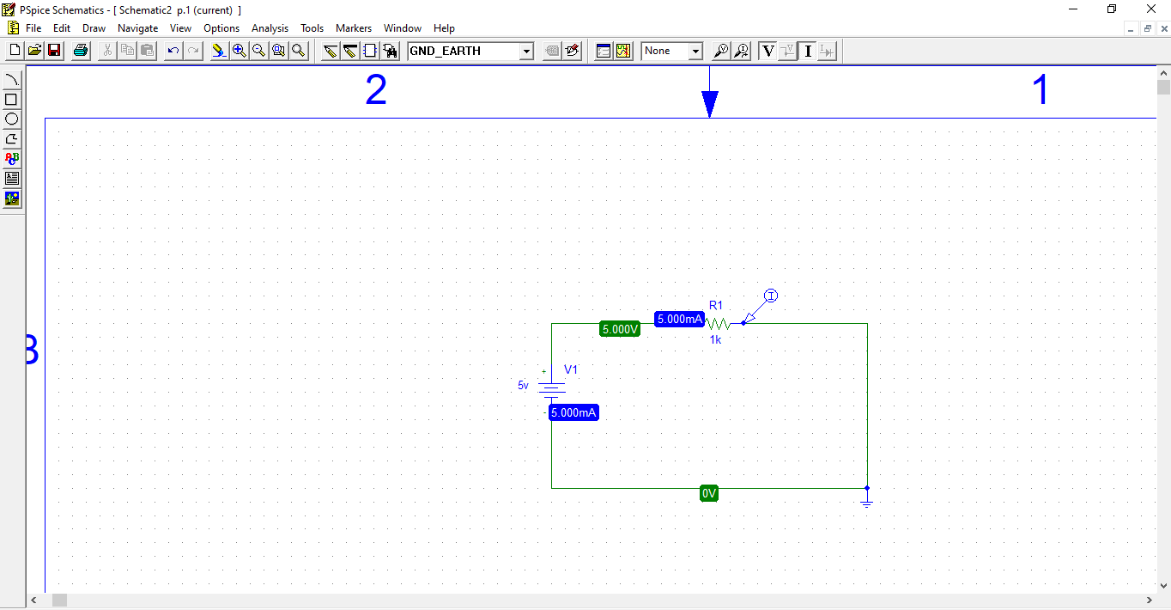

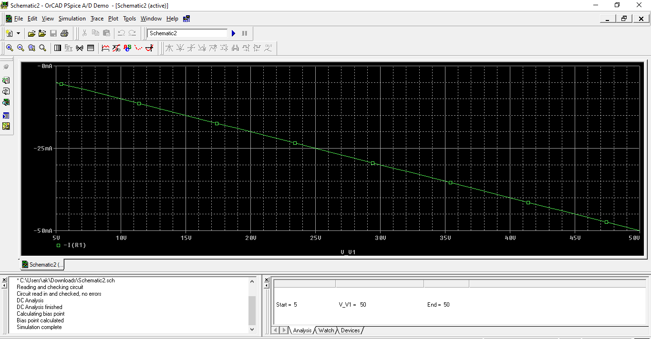

* The graph of the circuit is straight line which shows that current and voltage both are directly proportional to each other.

1. **For 10v:**

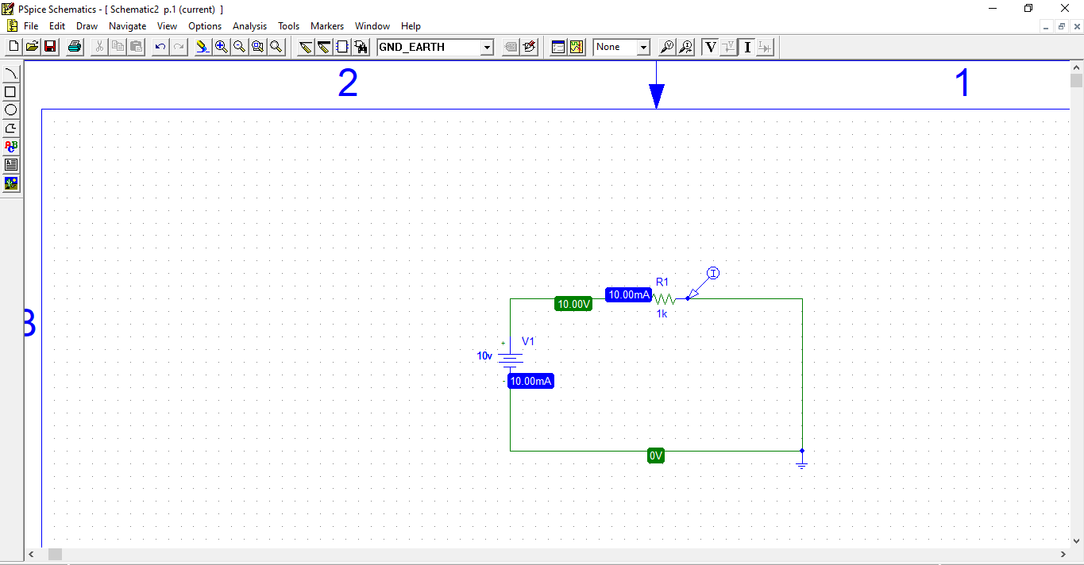

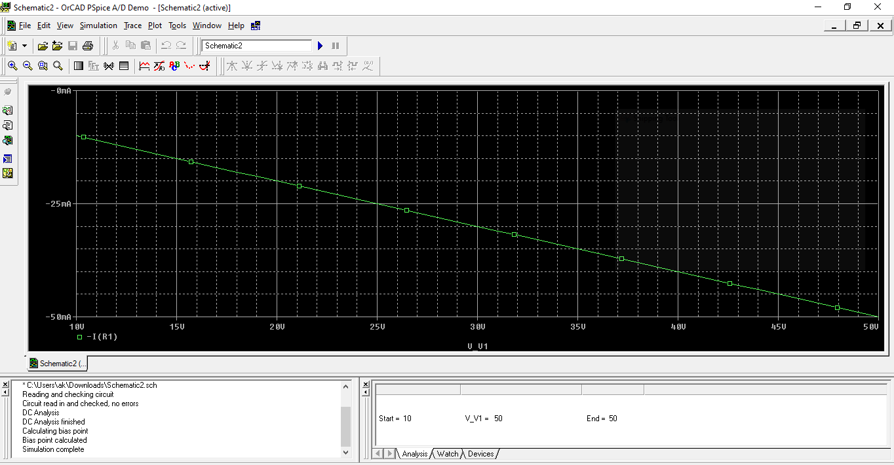

* The graph of the circuit is straight line which shows that current and voltage both are directly proportional.

1. **For 15v:**

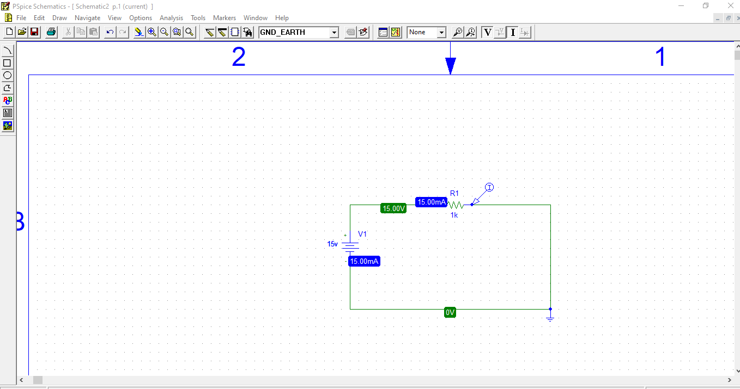

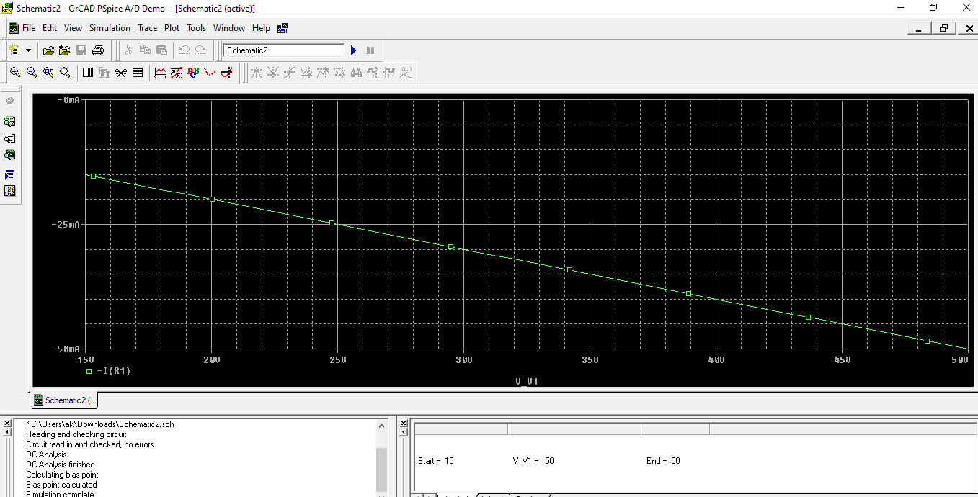

* The graph of the circuit is straight line which shows that current and voltage both are directly proportional.

1. **For 20v:**

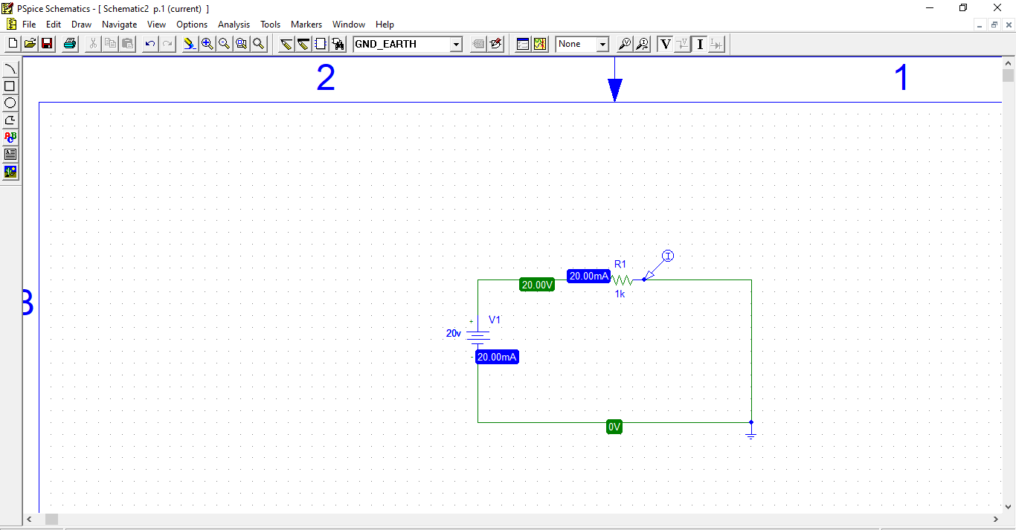

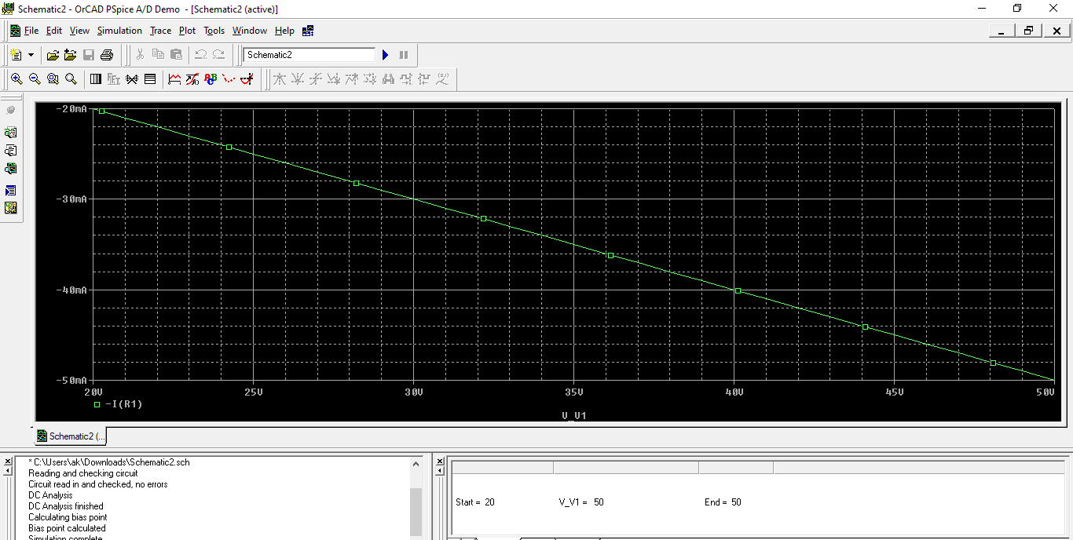

* The graph of the circuit is straight line which shows that current and voltage both are directly proportional.

1. **For 25v:**

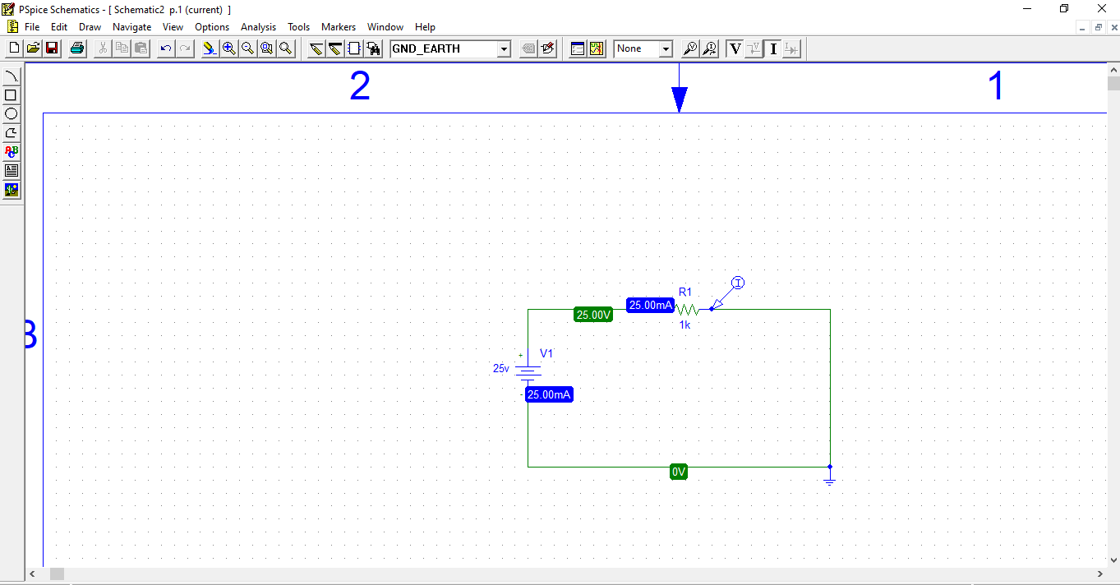

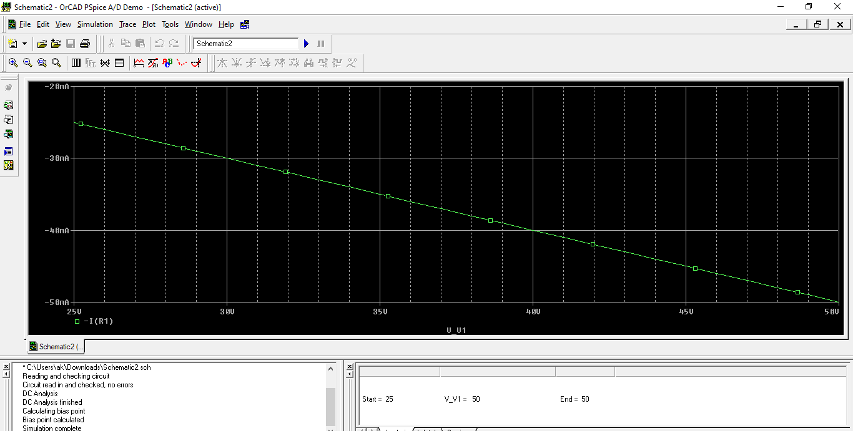

* The graph of the circuit is straight line which shows that current and voltage both are directly proportional.

1. **For 30v:**

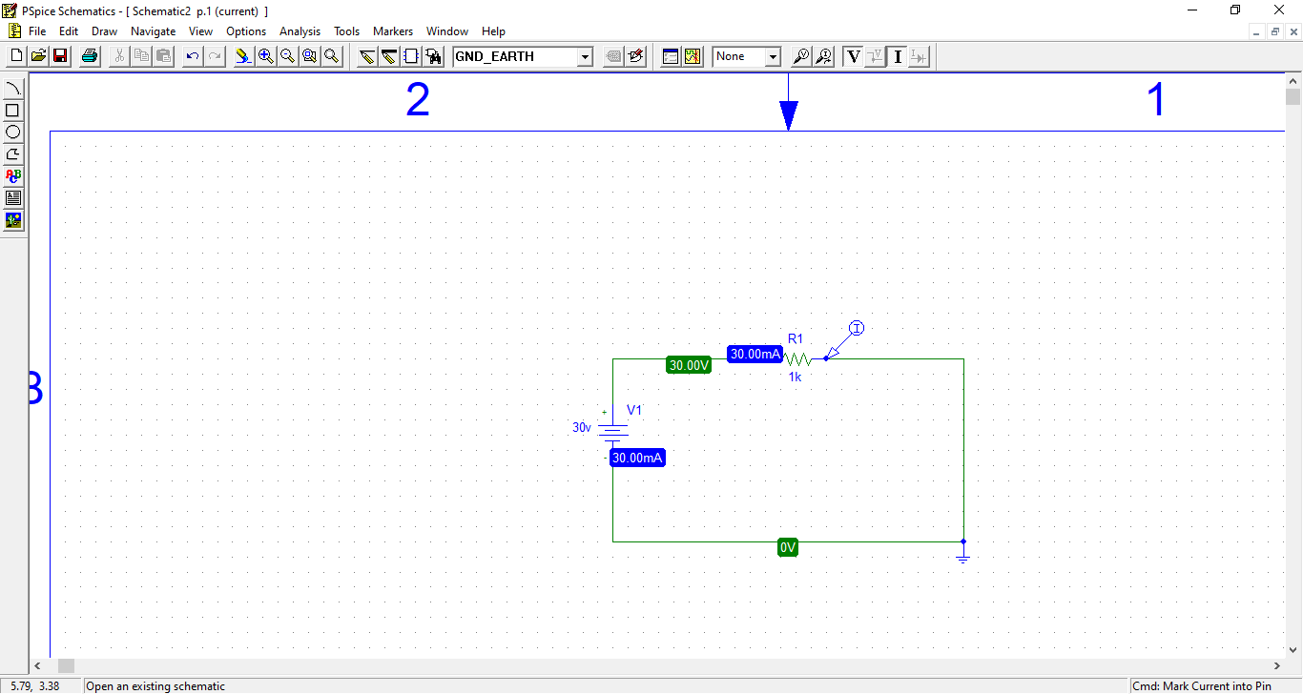

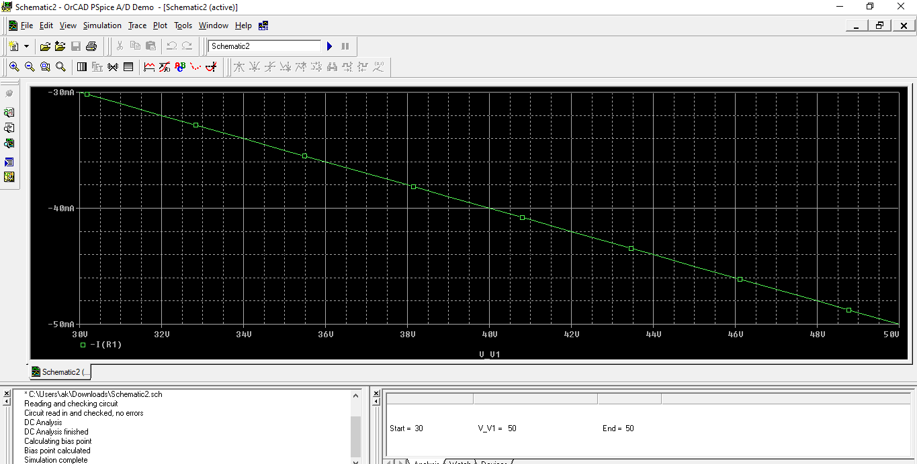

* The graph of the circuit is straight line which shows that current and voltage both are directly proportional.

Procedure:

1. Open PSPICE schematics.
2. In the tool bar click on Get new part button.
3. Then type r and click on Place button. Then toggle your mouse to the position where you want to place the resistor in your circuit.
4. After that type VDC and click on Place button. Then toggle your mouse to the position where you want to place the battery in your circuit.
5. Then type GND_EARTH and click on Place button. Then toggle your mouse to the position where you want to place the ground outlet in your circuit.
6. Now connect the components using Draw wire tool from the tool bar.
7. Click Simulate button from the tool to simulate your circuit.
8. Click Enable bias voltage display and Enable bias current display buttons from the tool bar to take the readings from the circuit.

Observation:

R = 1k Ω

|  |  |  |
| --- | --- | --- |
| Serial Number | Voltage (v) | Current (A) |
| 1. | 5v | 5mA (0.005)A |
| 2. | 10v | 10mA (0.01)A |
| 3. | 15v | 15mA (0.015)A |
| 4. | 20v | 20mA (0.02)A |
| 5. | 25v | 25mA (0.025)A |
| 6. | 30v | 30mA (0.03)A |

Conclusion:

Conclusion of Ohm's Law deals with the relationship between voltage and current in an ideal conductor. This relationship states that:

“**The potential difference (voltage) across an ideal conductor is proportional to the current through it. The constant of proportionality is called the "resistance", R”.** The graph of the circuit is straight line which shows that current and voltage both are directly proportional.